**Pie Chart Description**

**Question**

**The charts below give information on the ages of the populations of Yemen and Italy in 2000 and projections for 2050.**

**Summarize the information by selecting and reporting the main features, and make comparisons where relevant.**

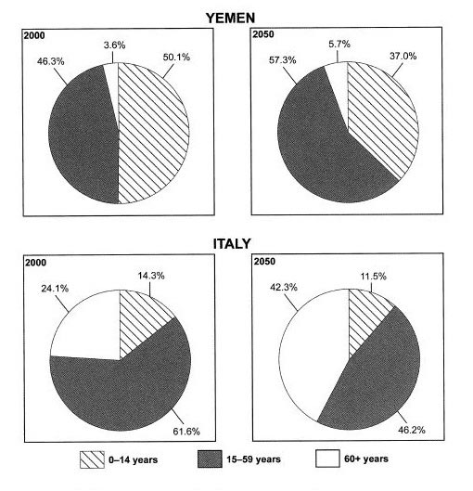

**Checklist**

In order to answer this task effectively, we need to ask ourselves some questions beforehand.

1. *What kind of chart is it?* This is a pie chart and we will, therefore, have to use different language sometimes as compared to other charts. For example, with pie charts, we are more likely to use the language of proportions.
2. *What does the title say about the chart?* The title gives us all the basic information we need to answer the question. We should read this at least twice to make sure we fully understand the question.
3. *What information is contained on both axes?* There are no axes in this question because it is a pie chart.
4. *What are the units of measurements?* The units of measurements are principally ages and percentages. We will, therefore, have to use specific language for percentages.
5. *What groups are compared?* There are two countries (Yemen and Italy) and three age groups.
6. *What is the time period?* This is very important because it will affect the tense we use. There are two different time periods- 2000 and 2050. We will, therefore, have to use past and future tenses.
7. *What is the most obvious thing that the data shows you?* The two most obvious things are that Italy had a much older population than Yemen in 2000 (or Yemen had a younger population) and both populations are predicted to be much older in the future.
8. *What is the most important or significant piece of information displayed?* The fact that Yemen has a very small proportion of people over 60.
9. *Can any comparisons be made?* Yes, the observations we made in points 7 and 8 above.
10. Is it a static chart or dynamic chart? There are four static charts but put together and they are dynamic i.e. it changes over time and this will be reflected in the language you use.

I am not suggesting that you write these ten questions out in the exam, it would take too long, however, I do tell my students to use this checklist when they are practicing. If you think about the ten things above, you have a much better chance of answering the question effectively.

**Structure**

For pie charts, I advise my students to use a simple four paragraph structure.

**Paragraph 1:** Sentence 1- **Paraphrase question**

**Paragraph 2:**  Sentence 1- [Overview](https://www.ieltsadvantage.com/2015/05/13/ielts-task-1-overview/) of **first main feature.**

Sentence 2- Overview of **second main feature.**

**Paragraph 3:**  2-3 sentences detailing **first** main feature.

**Paragraph 4:**  2-3 sentences detailing **second** main feature.

**Task**

Try using the checklist and structure above to try and answer the question **before** looking at the answer below. This is a really useful exercise because you will identify the areas you need to work on and make mistakes.

**Answer**

**The pie charts compare the proportions of Italian and Yemeni citizens in three age groups in 2000 and projections for 2050.**

**It is clear that Yemen had the younger population in the year 2000, and the same is predicted for the year 2050. The populations of both countries are predicted to get older over the 50 year period.**

**In 2000 just over half the Yemeni population were under 14, compared to just over 14% of Italians in the same age group. Only a very small percentage of people in Yemen were over 60 at 3.6%, in contrast to nearly a quarter of the Italian population. The largest group for Italy was the 15-59-year-olds with just over 60% while Yemen had 46.3% of its population in this category.**

**Yemen’s average age is set to increase with the proportion of over 60s increasing by just over 2% and the middle group rising by 11%, leaving the youngest group with a decrease of nearly 13%. It is envisaged that by 2050 the number of people in Italy over 60 will jump to 42.3%, the percentage of those in the youngest bracket will drop to 11.5% and the share in the middle category will decrease to 46.2%.**

**Examiner’s Report**

The answer addresses the task, reporting the main features and reporting enough detail for the reader to be completely informed. Very clear comparisons are made between the two countries throughout the essay. A very clear overview is given that gives a general picture of countries, all age groups and both times. The information is very well organised with good linking phrases such as ‘in contrast to’, ‘respectively’ and ‘It is envisaged’. Vocabulary is wide-ranging and accurate with words such as ‘Yemeni’, ‘bracket’, ‘category’ and ‘proportion’. Data is described well with words and phrases such as ‘over half’, ‘just over’, ‘jump to’ and ‘drop to’ put to good use. The range of grammatical structures is both wide-ranging and accurate with past, present and future tenses used effectively.

**Bar Chart Description**

**Question**: The chart below shows the total number of minutes (in billions) of telephone calls in the UK, divided into three categories, from 1995-2002.

Summarise the information by selecting a reporting the main features, and make comparisons where relevant.

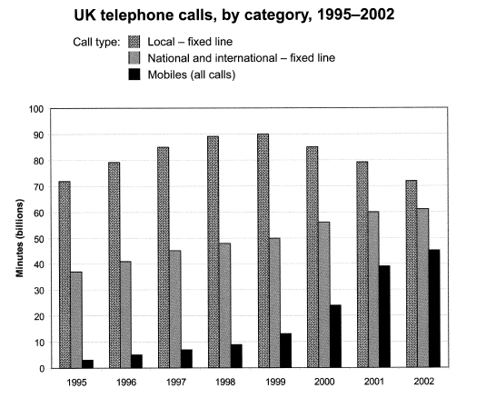

**Answer**

**The bar graph shows the combined time spent in billions of minutes, on three different kinds of phone calls in the United Kingdom, from 1995-2002.**

**Overall, local calls were the most popular over the whole period, with national and international calls and calls on mobiles second and third respectively. However, the number of minutes spent on international and national calls and mobiles both increased over the period, with mobile minutes increasing dramatically, thus narrowing the gap between the three categories by 2002.**

**Minutes spent on local calls fluctuated over the period, with just over 70 billion minutes in 1995, peaking at approximately 90 billion in 1999 and then steadily decreasing to just over 70 billion minutes in 2002.**

**National and international calls increased steadily year on year, from just under 40 billion minutes in 1995 to a peak of just over 60 billion in 2002. Mobile minutes increased rapidly from approximately 3 billion in 1995 to around 45 billion in 2002. Mobile phone usage nearly doubled from approximately 22 billion minutes in 2000 to 40 billion in 2001.**

You will notice that there are four paragraphs in this answer, each with a purpose. I advise all of my students to use this four-paragraph structure.

**Let’s look at it in more detail.**

**Paragraph 1**

Paraphrase question. This should be one sentence only, and it is how you should start all of your essays. Paraphrasing is just writing the sentence again to have the same meaning but with different words. See my post on [**how to paraphrase**](https://www.ieltsadvantage.com/2015/03/31/paraphrase-ielts/) for more detailed information on how to do this. In this example, I have changed phrases like ‘total number of minutes’ to ‘combined time spent’ and ‘divided into three categories’ to ‘three different kinds’.

**Paragraph 2**

In this paragraph, we outline the general trends or most noticeable general things about the chart. This is our [overview,](https://www.ieltsadvantage.com/2015/05/13/ielts-task-1-overview/)and the examiner will be looking for this. It isn’t easy to get a high band score without one. Notice that I have not included any numbers in this paragraph and used very general language to show what is happening.

Overall, local calls remain the most popular, despite a bit of fluctuation, and the other two also show a general increase. We are not looking at what happens between years in this paragraph; instead, we take a very broad view of the data. In the next two paragraphs, we can then describe these general trends in more detail.

**Paragraphs 3 and 4**

These paragraphs are our details paragraphs, and it is here that we describe the general trends. This is where we have to use the data.

You will notice that I have taken the **first** sentence in paragraph **2** and described it in more detail in paragraph **3**.

Then I have taken the **second** sentence from paragraph **2** and described it in more detail in paragraph **4**. This is a very logical way to order the information, will boost your marks for coherence and cohesion and make it easier for you to organise your thoughts and save time in the essay.

**Static or Dynamic?**

Before writing a bar chart or line graph answer it is important that we analyse the question correctly. Taking a few minutes to do this will help us write a clear answer that fully responds to the question. Just what the examiner wants us to do.

The first thing we need to do is decide if the bar chart is **static or dynamic**. **Static means that the data comes from one point in time. Dynamic means the data comes from more than one point in time.**

Whether a chart is static or dynamic will affect the information we choose to include in our answer and the kind of language (tense, [grammar](https://www.ieltsadvantage.com/2015/03/10/ielts-writing-task-1-grammar-guide/)etc.) we use.

If it is dynamic we will have to compare the different times and comment on the general trends over the time period.

If it is static we will have to compare the different variables, in this case countries, car price, GDP and time it takes for one person to buy a car.

**Main Features**

This means that we have to not only pick the most significant information from the graph and include it in our essay, but also decide which information is not important and should therefore not be included in our essay. One of the biggest mistakes you can make is including all the information you see.

So which information should you choose?

You should look for:

* **highest/lowest values**
* **biggest differences**
* **similarities**
* **significant exceptions**
* **anything else that really stands out**

There are 3 main features in this graph

1) It takes over 26 years for a Vietnamese person to buy a car.

2) Vietnam has the second highest average costs but the second lowest wages.

3) Cost of a car in Singapore is nearly 3 times the next most expensive.

**Structure**

I advise my students to follow a basic four paragraph structure for these kinds of questions.

**Paragraph 1**[Paraphrase](https://www.ieltsadvantage.com/2015/03/31/paraphrase-ielts/) the question using synonyms.

**Paragraph 2**Provide an overview of the main features. No need to include any data in this paragraph, just tell the examiner what is happening in general terms. If you had to describe the main features in two sentences, what would you say?

**Paragraph 3** This is where we get more specific and use data. Take 2 of the main features (from your overview) and describe them in detail using data from the chart.

**Paragraph 4**Simply do the same thing as you did in paragraph 3, but with two other main features (from your overview).

**Sample Answer**

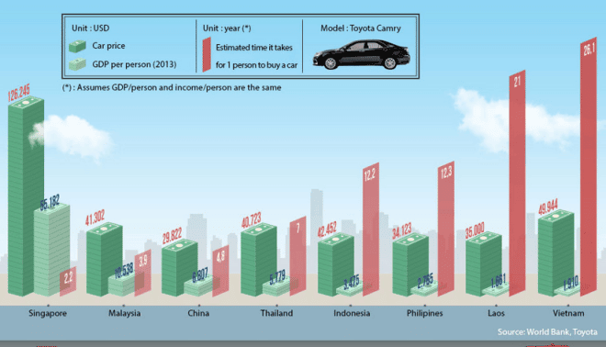

**The graph compares the GDP per capita, cost of a Toyota Camry and approximate length of time it takes for 1 citizen to purchase that mode of transport in eight Asian countries.**

**Despite having the second lowest average yearly income, it costs more to buy this car in Vietnam than in all but one other Asian nation. It also takes significantly longer for a standard person to buy an automobile in Vietnam than in any other state in Asia. On the other end of the scale, Singaporeans have to pay nearly three times more for their cars than the Vietnamese and it takes them the least amount of time to afford a motor vehicle.**

**It costs $49,944 to buy a Toyota Camry in Vietnam, but this dwarfs the average yearly income per person at just $1,910. It would therefore take a normal man or woman 26.1 years to save up for that particular car.**

**This is in contrast to Singapore where it costs $126,245 for that model of motorcar, however the average salary is much greater at $55,182. This means that it generally takes just over 2 years for a typical individual from Singapore to acquire this vehicle.**

**(200 words)**

This is just a chart that I saw on the internet, but it allowed me to make a very important point- you don’t have to mention everything on the graph. I only talked about 2 out of the 8 countries and I still wrote 200 words and answer the question fully. The key is finding the most significant data and not talking about anything else. Don’t worry, you won’t lose marks for not talking about everything, quite the opposite.

**Vocabulary**

This graph is also good for demonstrating how important it is to vary your vocabulary. There were four words that could have been overused in this essay- car, average, country and people. Instead of repeating them over and over again I used synonyms to show the examiner I have a wide vocabulary and gain extra marks. Here are the synonyms:

Car- Toyota Camry- automobile- vehicle- motor vehicle- motorcar

Average- approximate- normal- typical- standard

Country- countries- nation- state

People- citizen- man or woman- individual

**Line Chart Description**

**Task**

**The graph below gives information from a 2008 report about energy consumption in the USA since 1980, with projections until 2030.**

**Summarise the information by selecting and reporting the main features and making comparisons where relevant.**

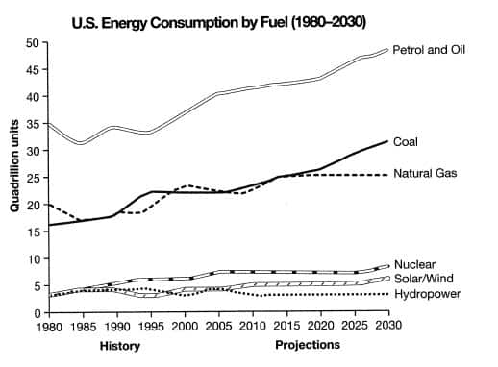

The line graph shows energy consumption by fuel type in the United States from 1980-2008, with projected use until 2030.

Overall, fossil fuels have been the dominant type and will continue this trend into the future. Nuclear and renewable energy sources have represented a small but significant proportion of total energy use, and despite small projected gains, they are projected to continue doing so.

Petrol and Oil command the biggest share with 35 quadrillion units (35q) in 1980, rising to approximately 40q in 2008, and this trend is set to continue with a projected value of nearly 50q in 2030. In 1980 natural gas and coal came in second and third, with around 16q and 20q, respectively. However, coal overtook natural gas in 1990 and, despite some fluctuation, is set to be the second most used fuel in 2030 with just over 30q. It is predicted that natural gas will level off and remain relatively constant at about 25q.

Nuclear and renewable energies all represented around 4q in 1980 and fluctuated up until 2008.  It is speculated that nuclear energy will reach 10q by 2030 and solar/wind around 5q, with hydropower dropping and then remaining constant at approximately 2q.

**Paragraph 1** Paraphrase question

**Paragraph 2** [Overview](https://www.ieltsadvantage.com/2015/05/13/ielts-task-1-overview/)of 2 main features. You will notice that I have included no numbers and used very general language.

**Paragraph 3** Details of the first main feature. Here I have gone into more detail about the first general point I mentioned in the previous paragraph.

**Paragraph 4** Details of the second main feature.

You will notice that I have written a lot more about the first feature. I did this because I think the most used fuels and more significant. You will also notice that I shortened ‘Quadrillion units’ to ‘q’. This is acceptable if you tell the examiner this by putting it in brackets, as I have done.